What Makes a Good restaurant

**Introduction**

1. Dataset Properties:

For our project we used Yelp dataset downloaded from Yelp website. The dataset contains around 4.7 Million reviews, 1.1 Millions unique users data, and around 150K unique business data. The data are available in json format. Out of total businesses around 51K are restaurants.

/Users/bhaskarmishra/Python/CSE258/Assignment2/Yelp-Review-Analysis-And-Prediction/Plots/stateRestaurantDistribution.pdf

Fig 1 : Geographical Distribution of Restaurants

**2. Literature Survey:**

Many works have been done related to rating prediction task in the past. One of the most famous method was latent factor model. This model was introduced during Netflix prize competition by Simon Funk[10]. This method became famous after its introduction and following which many variants of latent factor models were introduced.

Koren, the winner of Netflix prize competition, proposed one simple latent factor model by adding user and item biased terms in the basic matrix factorization model. Later, he also introduced an algorithm called SVD++ that outperformed Netflix’s Recommender system[4][5][7]. SVD++ exploited both implicit and explicit feedback from the users to improve the rating predictions[4].

Latent Factor Model uncovers latent features from the ratings discarding the reviews text. Several topic modeling techniques have been developed to learn hidden topics from reviews text. Latent Dirchlet Allocation (LDA) is one of the common unsupervised learning algorithms to discover the hidden topics [9]. There are various other topic modeling methods like Latent Semantic Analysis(LSA), Probabilistic Latent Semantic Analysis.

Various models have been described that uses LDA for topic modeling and rating predictions. One of the method described was averaging over all reviews ratings that contained the given topic to calculate the hidden topic rating[2]. One more study by J.McAuley fuses latent rating dimensions and latent review dimensions to predict the star ratings more accurately. This model gives the RMSE of 1.176 on Yelp Challenge Data.

In this project, we will try to incorporate some of the above mentioned concepts to make the rating predictions tasks more accurate.

1. **Statistics and Exploratory Data Analysis**

It was weird to observe that approximately 50% of the restaurants data came from just 2 states – Ontario, and Arizona. Fig 1 displays the percentage distribution of restaurants across different states.

/Users/bhaskarmishra/Python/CSE258/Assignment2/Yelp-Review-Analysis-And-Prediction/Plots/ratingStateWise.pdf

Fig 2.a : Geographical distribution of restaurants with different star rating

../Yelp-Review-Analysis-And-Prediction/Plots/overallBusinessrating4.pdf

Fig 2.b : Number of restaurants with different star rating

../Yelp-Review-Analysis-And-Prediction/Plots/ratingOverallDistribution.pdf

Fig 2.c : Number of Reviews with different star rating

For our analysis purpose, we focused on restaurants of Arizona. The dataset contained data of around 10k restaurants in Arizona. Out of total restaurants, approximately 800k reviews have been given to restaurants in Arizona. Stars ratings in the review indicates the success of the restaurants. We found that there are only few restaurants, distributed geographically, with average rating of either 1 or 5. Around 50% of the total restaurants have average rating of either 3.5 or 4. Fig 2.a displays the geographical distribution various star ratings. We also plotted the distribution of review rating and it surprised us to note that more than 70% of the reviewed restaurants belonged to either 4 star category or 5 star category. It indicated that the restaurants with good ratings have been reviewed (or visited) more by users even though they are present less in numbers compared to other categories. Fig 2.c displays the plot of number of reviews with different star ratings.

../Yelp-Review-Analysis-And-Prediction/Plots/WeeklyTimeSeriesAnalysis.pdf

Fig 3.b: Time Series Analysis (Monthly Analysis)

/Users/bhaskarmishra/Python/CSE258/Assignment2/Yelp-Review-Analysis-And-Prediction/Plots/DailyTimeSeriesAnalysis.pdf

Fig3.a: Time Series Analysis (Weekly Analysis)

Time Series Analysis

We found that the restaurants in Arizona have been reviewed from February 2005 to July 2017. We tried to find weekly, monthly, and annual trends of reviews given to restaurants.

We found that restaurants received maximum number of reviews every Sunday, and minimum number of reviews during Tuesday –Thursday. It was probably because users are free mostly on weekends and hence they prefer to visit restaurant and review them on Sunday. Fig 3.a shows the weekly trend. Similarly, we found restaurants received minimum number of reviews in the month of January and maximum number of reviews in the month of April. Fig 3.b shows the monthly trend in number of reviews. From fig 3.c we observe that number of reviews in restaurants have increased significantly from 2005 to 2017. Increasing popularity of Yelp over time could be one of the reasons for this change.

../Yelp-Review-Analysis-And-Prediction/Plots/MonthlyTimeSeriesAnalysis.pdf

Fig3.c: Time Series Analysis (Yearly Analysis)

We started with plotting the star rating vs total number of reviews a restaurant has received and we got the distribution as shown in fig 4.

/Users/bhaskarmishra/Python/CSE258/Assignment2/Yelp-Review-Analysis-And-Prediction/Plots/RatingReviewCountPlot.pdf

Fig 4 Rating VS Review Count

**\*\*\*\*\*\*\*\*\*\*\*\*\*\*\*\*\*\*\*\* Feature Based Models \*\*\*\*\*\*\*\*\*\*\*\*\*\*\*\*\*\*\*\*\*\*\*\*\***

**Feature Selection :**

We used the review.json and business.json files for feature selection. The review .json  contains  fields like “user\_id” , “business\_id”, “review\_text” etc. along with the associated ratings. It also consists of some categorical fields like “funny”, “cool”, “useful” etc. We however didn’t use these categorical fields in our Models because most of these fields were either extremely skewed or very  sparsely populated with many null entries. In order to rule out the significance of these categorical variables , we performed chi-square testing and as expected, we found these features to be highly insignificant at a type I error rate of 0.05.

A lot of attributes from the  business.json file were also used in our prediction. Most of these predictors were One Hot Encodings of several categorical variables like "BusinessParking", "GoodForMeal.lunch", "Alcohol\_beer\_and\_wine", "HasTV", WiFi\_free etc. A few continuous valued predictors were also fed to these models like the "userAvgRating" , "userReviewCount" etc. Overall, a total of 38 predictors were  from both review.json and business.json were used in our models. The chart below represents the order of Significance of these predictors based on the p-values obtained from Linear Regression. At  a significance level of 0.05 , we observed that user features  like “userAvgRating” and “userReviewCount”  were  highly significant . We also found Business features like “OutdoorSeating”, “WiFi\_free”, “NoiseLevel\_quiet” to be highly significant predictors of the ratings.

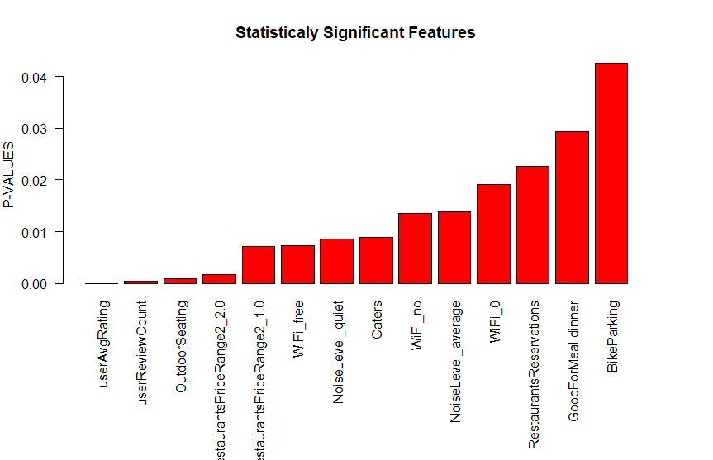

**Models :**

The 200K data was randomly split into 150K training and 50K testing sets for all the Feature Based Models below. Grid Search was used to tune the hyper-parameters of all these Models.

We performed mean normalisation and feature scaling for all our Models.

**Linear Regression:**

We used the Ordinary Least Squares (scipy.linalg.lstsq)  Regressor with fit\_intercept parameter  set to True. We obtained an MSE of 1.23127597354 and an RMSE of 1.1096287548271544 on our test set for our Linear Regression Model.

**Ridge Regression :**

We used the standard Linear least squares with l2 regularization for our Ridge Regression Model with regularisation parameter lambda = 1.0 and fit\_intercept parameter set to True.

We obtained an MSE of 1.23127931759  and an RMSE of 1.109630261660905 on our test set for our Ridge Regression Model.

**Support Vector Regression (SVR):**

We used the standard libsvm based Epsilon-Support Vector Regression Model with  C set to 1 and epsilon set to 0.1. Rbf kernel and degree 3 polynomial was used for the fitting.

We obtained an MSE of 1.26881663173 and an RMSE of 1.1264176098262875 on our test set for our Support Vector Regression

**Random Forest Regression :**

We used the sklearn Random Forest Model with no. of trees i.e. n\_estimators  as 10 . We chose the optimisation metric as mse with minimum split i.e min\_samples\_split  set to 2 and bootstrap set to True. We obtained an MSE of 1.43051313003 and an RMSE of 1.1960406055105643 on our test set for our Random Forest Regression.

**AdaBoost Regression :**

We used the AdaBoost Regression model with base\_estimator set to DecisionTreeRegressor, no. of trees i.e. n\_estimators set to 50 and a learning\_rate of 1. We used the square loss function for the fitting.We obtained an MSE of 1.35814161741 and an RMSE of 1.1653933316308949 on our test set for our Random Forest Regression.

**Neural Net Regression :**

We also tried a Neural Net Regressor on the Model. The Plot below depicts the Neural Net

Architecture using resilient backpropagation with 1 hidden layer consisting of 20 neurons.

In order to avoid overfitting, we used a drop-out rate of 50%. We obtained an MSE of 1.21821283799  and an RMSE of 1.1037267949948337 on our test set for our Neural Net Regression.

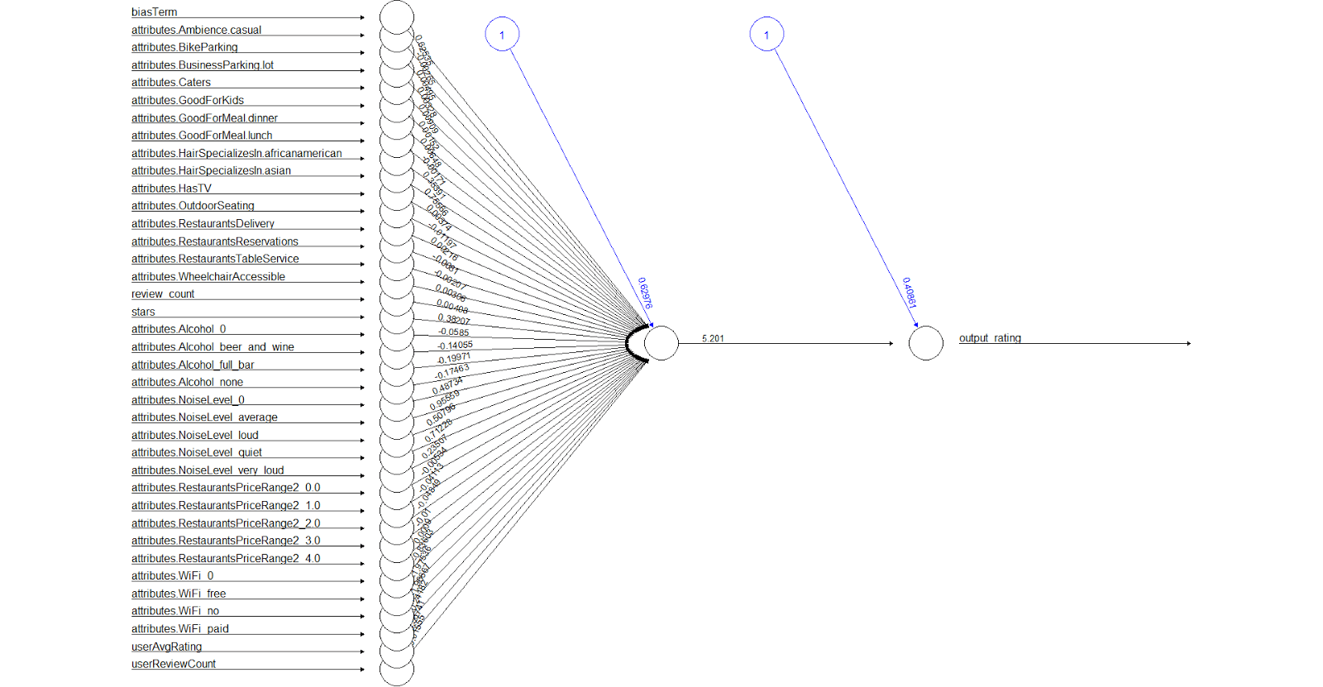

**Observations :**

Surprisingly Ridge Regression and Linear Regression outperformed more complicated Nonlinear Models like SVR (with a polynomial kernel of degree 3), Random Forests and AdaBoost based on the RMSE obtained on the Test set.This might probably be attributed to the problem of Over-Fitting of Nonlinear Models.

This bar plot below shows the Root Mean Squared Error (RMSE) obtained by trying a bunch of different Linear and Nonlinear Models like Linear Regression, SVR, Ridge Regression, Neural Nets as described above.  As evident from the Bar Plot above, Neural Net outperformed every other model with an RMSE of 1.1037267949948337 on the test set.

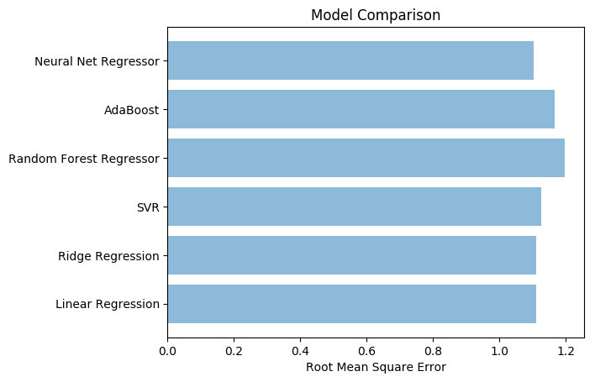

**Latent Factor Model**

In order for a restaurant to be a success, it must consider the tastes of the users and then try to improve on those properties that the users look for. To discover these properties we must take into account the reviews of the users. We start by plotting wordcloud of all 5 star reviews and 1 star reviews to check what positive and negative aspects of restaurants have been discussed by the users. Fig 5.1 shows the wordcloud of all 5 stars reviews. It can be seen that some most frequent words occurring in restaurant with 5 star ratings are a combination of positive adjectives, and some nouns like - “love”, ”great”, ”service”, ”time”, ”fresh”, ”food”, ”best”, ”delicious”, ”friendly” etc. So, it can be inferred that properties like friendly staffs, fresh and delicious foods, great service etc. have been liked by users, and thus, these properties contributed to higher ratings.

/Users/bhaskarmishra/Python/CSE258/Assignment2/Yelp_Data_Analysis/Plots/5StarWordCloud.pdf

Fig 5.1: Word Cloud of all 5 Star Ratings

Similarly, by looking at the wordcloud of 1 star rated reviews in Fig 5.2 it can be seen that the negative adjectives, and some nouns like “never”, ”time”, “service”, ”food” etc. have been discussed. It can be inferred that these restaurants lack in some of the properties like food quality, staffs behavior, punctuality, service quality etc, and they need to improve on these properties in order to receive higher ratings.

/Users/bhaskarmishra/Python/CSE258/Assignment2/Yelp_Data_Analysis/Plots/1StarWordCloud.pdf

Fig 5.2: Word Cloud of all 1 Star Ratings

Models:

For prediction tasks, we used 200k randomly shuffled reviews data from Arizona as training data, 100k reviews data as validation data, and next 100k reviews data as test data.

1. Latent Factor Model:

Equation Here:

Explanation:

This model uncovers the latent(hidden) features from ratings given by user ‘u’ to a restaurant ‘i’. However, it completely ignores the reviews given by users.

1. Latent Dirchlet Allocation (LDA)

Latent Dirchlet Allocation (LDA) is a generative statistical model for text, which is used as a topic model to discover hidden features from text reviews. In LDA, each document ‘di’ is viewed as a collection of different topics, which is a K-dimensional stochastic vector. Each topic is a collection of a fraction of words that describes each topic with certain probability.

We used LDA on our entire training dataset to find out hidden topics from reviews. We tried models with different values of latent factor(K), and finally we chose the value of K as 40. Table 1 shows few topics that we extracted by running LDA on the entire training data set. For example, *Staff* topic is made up of words like “order”, “manager”, “employee”, “service” etc. Similarly, the topic *Sea Food* is made up of words like “sushi”, “roll”, “fish”, “tuna”, “salmon” etc. Each word inside a topic appears with a probability of it being associated with that topic.

|  |  |  |  |  |
| --- | --- | --- | --- | --- |
| Staff | Service Time | Sea Food | Menu | Cleanliness |
| order | minute | Sushi | menu | bathroom |
| manager | order | roll | Wine | dirty |
| service | Time | fish | restaurant | floor |
| employee | came | tuna | dish | parent |
| staff | table | salmon | item | movie |
| owner | service | fresh | course | coke |
| counter | ordered | Japanese | meal | clean |

|  |  |  |  |  |  |
| --- | --- | --- | --- | --- | --- |
| Payment | Group | Desserts | Food (2) | Beer | Night  Time |
| card | table | cream | pizza | beer | late |
| dim | room | desserts | italian | selection | night |
| cash | dining | chocolate | pasta | nacho | club |
| sum | experience | ice | crust | tap | hit |
| credit | reservation | cake | sauce | brew | open |
| stated | group | sweet | cheese | bar | scottsdale |
| continued | party | strawberry | gluten | local | miss |

Table 1: Topics Extracted From Reviews by LDA

Let’s take an example of a 1 star review given below:

*“Absolutely hot garbage and overrated*

*Please spend your hard earned money elsewhere. My room smelled like cat urine and the sinks and shower were slow draining, great place if you like cold showers in the morning time. I would rather stay in a Marriot Courtyard any day of the week.”*

The top 5 topics returned by this review are – “place”, “Room”, “Payment”, “Service”, “Visit”. It’s clear from the topics that in order to improve the ratings, the restaurant owner must try to improve attributes like Room condition, Service, staying place etc.

**Interesting Findings:**

We used LDA to find similarity between tastes of users in Arizona and users of Ontario. For this, we ran our model separately on 5 stars rated reviews of Arizona and reviews of Ontario and found the results as shown in table 2. The table displays the top 4 topics about which users discuss more when they give 5 star rating to a restaurant. The result shows that attributes like Service Time and Quality are more important to restaurants in Arizona, whereas attributes like Menu(variety of items), delicious food items are more important to restaurants in Ontario. It also shows that attributes like place, and staff behavior are important for both the states.

|  |  |
| --- | --- |
| **Arizona** | **Ontario** |
| Place (25%) | Place (24%) |
| Service Time (9%) | Staff (11%) |
| Staff (6.6%) | Menu (6%) |
| Quality(4.6%) | Delicious Items (4.5%) |

**Latent Model Comparison:**

|  |  |
| --- | --- |
| **Models** | **RMSE** |
| Latent Factor Model (LFM) | 1.268 |
| Latent Dirchlet Allocation (LDA) | 1.284 |
| LFM + LDA | 1.286 |

**Results and Comparison**

< Will Edit it and Give you in the morning>

**Conclusion :**

In this report, we have analysed both Feature Based and Latent Factor models for predicting the ratings of restaurants. We observed that Feature Based Models gave slightly better results than Latent Factor models for our dataset. This can be attributed to the fact that we chose a relatively smaller subset (200K data points ) of the entire data (5 million data points) and therefore Latent Factor Models were unable to discover all the latent features for prediction. On the other hand, we were able to obtain very fine-grained predictors for our Feature Based Models from business.json and review.json which increased the predictive power of our Feature Based Models.

We also observed that amongst the Feature Based Models, simple Linear Models like Linear Regression and Ridge Regression gave better results than more complex nonlinear models like SVR, Random Forest and AdaBoost. This can be potentially attributed to the fact that these nonlinear models might have been slightly overfitting the training data even with enforced regularisation. In order to test this, we trained a Neural Net Model with a high dropout rate of 50%  to counter the low bias problem associated with nonlinear models. We saw that the Neural Net model gave us the best results in term of MSE. Also, amongst the Latent Factor Models the results obtained were pretty close to each other with the basic version of Latent Factor Model (LFM) outperforming the Latent Dirichlet Allocation (LDA)  and LFM+LDA model by a small margin.Even though the feature based models outperformed the Latent Models, we  observed how LDA Models can harness the power of text reviews to help us identify the set of attributes/ Topics which are typically associated with good Restaurants and similarly for the bad ones.

**Future Work**

One interesting follow-up of our analysis would be see whether increasing the number of Training Data from 150K to 5 million would allow Latent Factor Models to outperform feature based models in terms of MSE.  We would also be interested in extrapolating our work on both Feature Based and Latent Factor models to examine the Temporal effects in our Models.

References:

[1]J.McAuley, Hidden Factors and Hidden Topics: Understanding Rating Dimensions with Review Text.

[2]James Huang, Improving Restaurants by Extracting Subtopics from Yelp Reviews

[3] Jack Linshi, Personalizing Yelp Star Ratings: a Semantic Topic Modeling Approach

[4]Y. Koren, R. Bell, and C. Volinsky. Matrix factorization techniques for recommender systems. *Computer*, (8):30–37, 2009.

[5]  R. Bell, Y. Koren and C. Volinsky. The BellKor 2008 Solution to the Netflix Prize. 2008.

[6] Zhou Tong , A TEXT MINING RESEARCH BASED ON LDA TOPIC MODELLING

[7[ Y. Koren. Factorization meets the neighborhood: a multifaceted collab- orative filtering model. In *Proceedings of the 14th ACM SIGKDD in- ternational conference on Knowledge discovery and data mining*, pages 426–434. ACM, 2008.

[8] J. J. McAuley and J. Leskovec. From amateurs to connoisseurs: model- ing the evolution of user expertise through online reviews. In *Proceed- ings of the 22nd international conference on World Wide Web*, pages 897–908. International World Wide Web Conferences Steering Com- mittee, 2013.

[9] Blei, Latent DirchLet Allocation

[10] Netflix update: Try this at home. http://sifter.org/ simon/journal/20061211.html.